Fortumo in-app billing integration guide

This doc explains how to integrate operator payment and Nook credit card payment into an existing android app. It consists of 5 parts and should be read in order as each part is built on top of previous part.
- Part1. An android app Clock without billing
- Part2. Configure Fortumo payment
- Part3. Create Clock with Fortumo operator billing
- Part4. Integrate NOOK credit payment to Clock
- Part5. Create Clock with Fortumo and Nook payment
Please get following items ready before continue:
  - Be an experienced android developer and have set up Android development environment, If not, learn it from here.
  - An android device with SIM card . The SIM card needs to be sms and data service enabled, and from one of the countries and operators listed here. Note the examples below use SIM cards from Estonia, China or USA

PART1: Clock - no billing
Clock is a simple Android application that displays device time in HH:MM:SS format. It also allows users to count milliseconds. Each time user starts the Counter, it spends one Point. User can top up Points without any payment. The current Points number is displayed and updated according.

Clock has two versions Trial and Full License. The only difference is either “Trial Version” or “Full Version” showing on the main screen. The application starts as Trial version and can be upgraded to Full version. Once it is in Full version, it can not be down-graded to Trial version.
For testing purpose, press the “Clear all data for testing” Button, restart the application, then it will go back to Trial version.

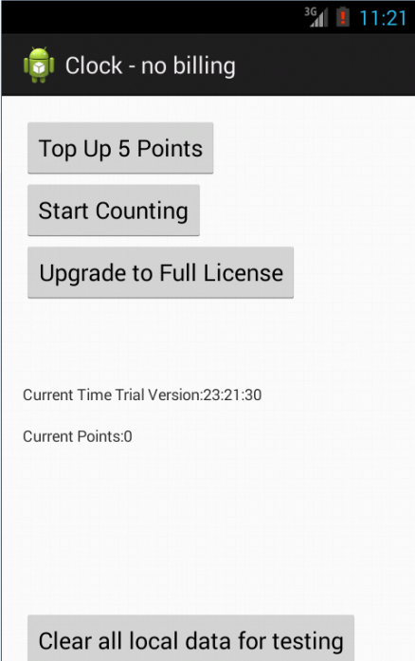 | 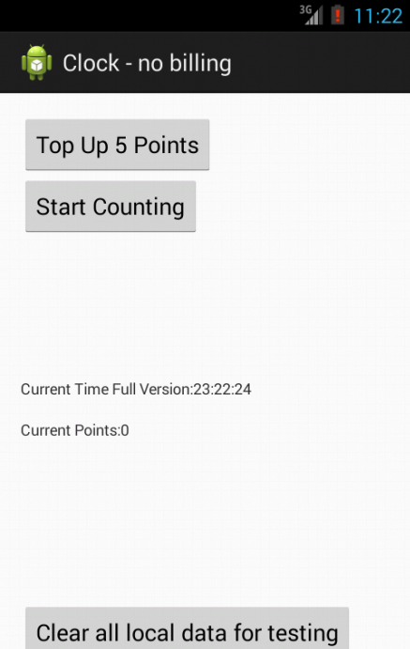
Figure 1.1 when start, it is in Trial Version and Current Points is zero. No response after pressing the Start Counting | Figure 1.2 after upgrade to Full License

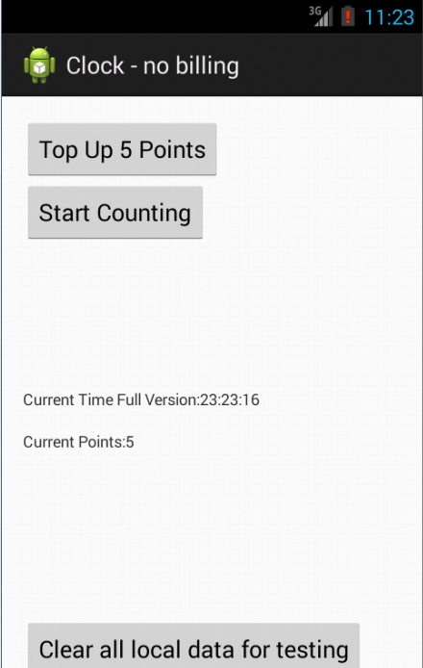 | 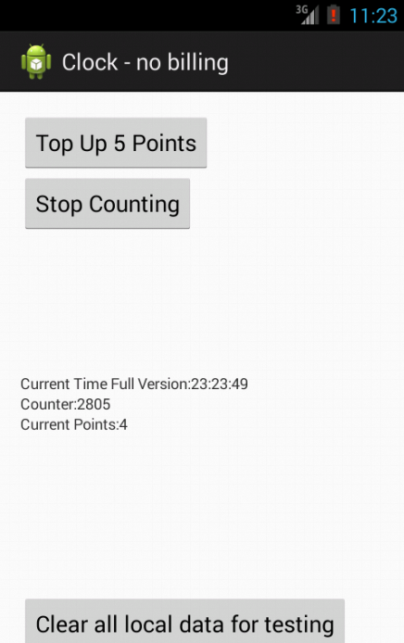
Figure 1.3 after press the top up button once, the Counter changed | Figure 1.4 after start counting, 1 Point is spent

Your Tasks
- Download the Step1 project files, load it into the Android IDE and run it in Emulator
- Run Step1.apk application on a Android device
- Review the Step1 code in IDE. There are two classes ClockMainActivity and StatusData. The ClockMainActivity displays the UI and response to user’s requests. The StatusData stores and manages Current Points, Version flag (Trial / Full Version) in application preference

Part2. Billing Set Up
In next sections, we need to add two types of mobile payments to Step1 application: pay for upgrading to Full License, and top up Points.

Fortumo In-App Payments SDK offers two types of sellable goods: Non-consumable items and Consumable items. Their definitions are here. In Clock application, Paying for upgrading to Full License is a Non-consumable item; paying for Points is Consumable items.

Your Tasks
- Follow the instructions to create Fortumo developer account and configure the two payment goods with following parameters:
  - Clock Points
Name: CLOCK POINTS
Type: Consumable ((Virtual credits)
Countries: China, Estonia, USA
1 Point costs 1 RMB.. Prices for 1 Point will be set accordingly for USA and Estonia markets
  - Clock Upgrade
Name: CLOCK UPGRADE
Type: Non-Consumable ((Single Item)
Countries: China, Estonia, USA
Prices: 1RMB for China, 1.6 Euro for Estonia and 2.99 USD in USA

The URL that the payment requests be forwarded is configured to a server side application to log all the payment related transactions. We do not configure them for these two payment goods.
- Download In-App Payment Android SDK from here

Part3. Clock with Fortumo billing
Now let’s enable mobile payment in Clock with Fortumo billing SDK. The new application Step2 has same main screen as Step1 application. When the Upgrade and Top up buttons are pressed, additional payment screens will be shown.

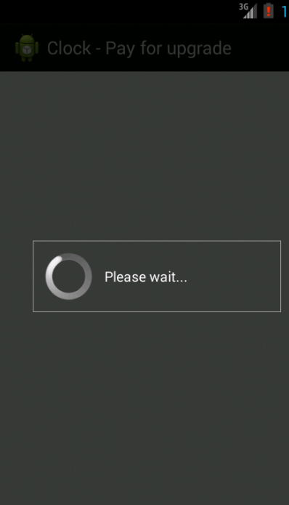 | 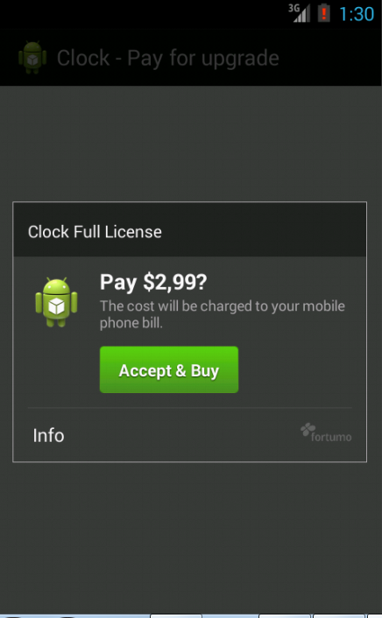 | 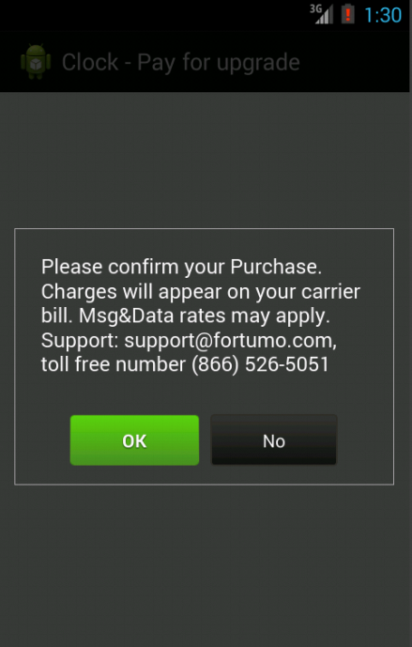
Figure 3.1 After press the Upgrade to Full License button, get the pricing information from Fortumo server | Figure 3.2 Confirm the item and payment | Figure 3.3 Confirm charging to phone bill

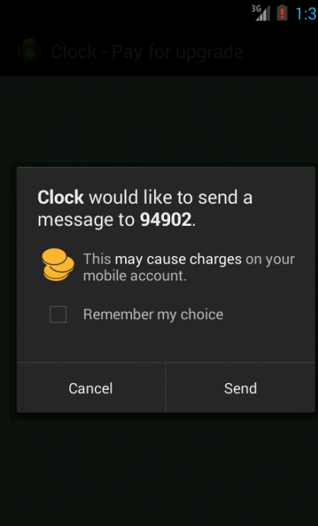 | 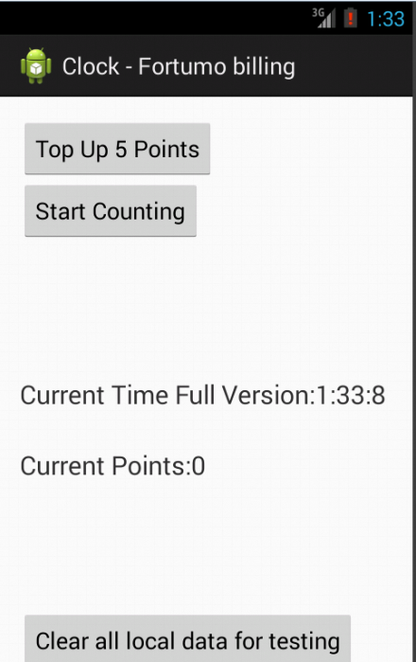
Figure 3.4 confirm sending payment SMS to operator | Figure 3.5 Upgrade successfully

Here are Step2.apk and Step2 project source code.
Your Tasks
- Copy Step1 project into Step2 project, and rename class com.clock.step1 to com.clock.step2 in all class and configuration files. Make sure the application is workable under Step2 project
- Follow the instructions to download the Fortumo SDK and add to the libs of Step2 project
- Follow the instructions to change the configuration AndroidManifest.xml. There are three activity screens ClockMainActivity, Pay4Upgarde and Pay4Points. The server sends Payment notification broadcast message PAYMENT_BROADCAST_PREMISSION. The PaymentStatusReceiver is the only receiver of the notification.
- Follow the instructions, add three classes to handle the upgrade payment (Pay4Upgrade), Points purchase (Pay4Points) and processing the payment result (PaymentStatusReceiver)
  - Change ClockMainActivity class. When the Upgrade button is pressed, it starts Pay4Upgrade.
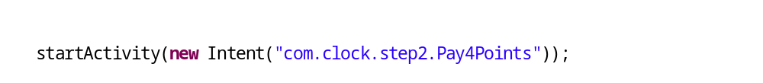When the Top up button is pressed, It starts Pay4Points:
In the onResume() function, it updates current Points value and version flag from StatusData
  - In Pay4Points, enable message sending, then make the payment by calling makePayment(). As it is a Consumable item, set builder.setConsumable(true);
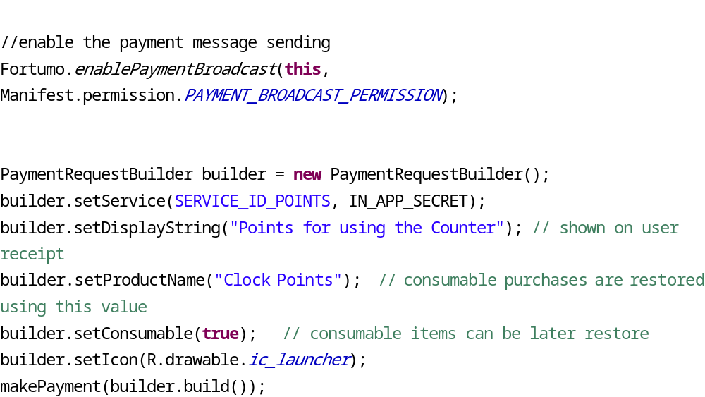
  - In Pay4Upgrade, enable message sending, then make the payment by calling makePayment(). As Upgrade is a Non-Consumable item, set builder.setConsumable(false);
  - After server processes the payment requests from Pay3Upgrade and Pay4Points, it sends responses to PaymentStatusReceiver. The PaymentStatusReceiver checks the status code and Service ID, and updates StatusData object accordingly if payment is successful
  - Run the Step2 project and debug and make it works in Emulator and on device. Refer to the sample project here.

Part4. Clock with NOOK billing

In this section we create Clock with NOOK billing project Step3 from Step2 project. Step2 and Step3 have same active screens, use same Fortumo library. The AndroidManifest.xml file, Pay4Points, Pay4Grade and PaymentStatusReceiver classes need to be changed

Your Tasks:

Copy Step2 project into Step3 project, and rename class com.clock.step2 to com.clock.step3 in all class and configuration files. Make sure the application is workable under Step3 project

Follow the instructions to change AndroidManifest.xml. Note the notification message is changed to PAYMENT_INFO_BROADCAST_PERMISSION and user-permission fields to be changed

Follow the instructions to make changes to following classes

Change Pay4Points to make NOOK payment call

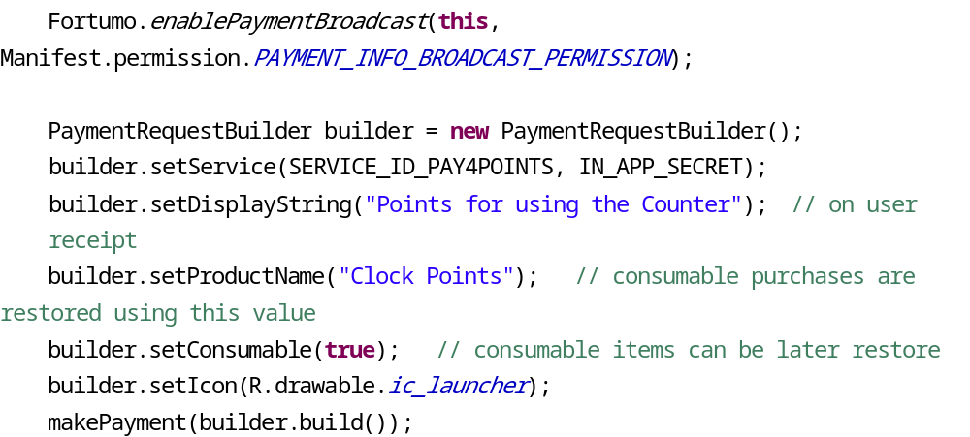

Change Pay4Upgrade to make NOOK payment call

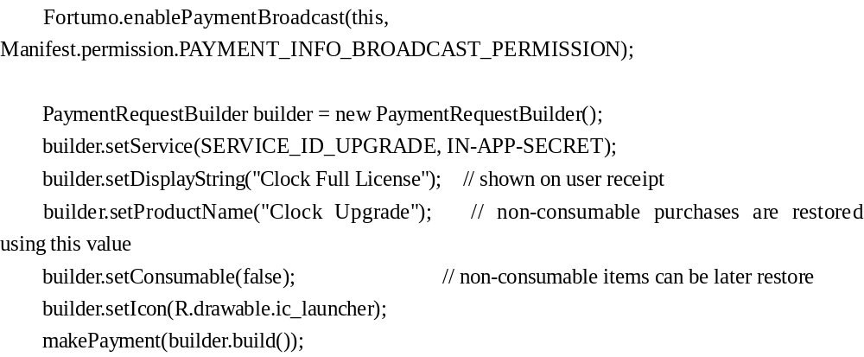

Change PaymentStatusReceiver to handle NOOK payment response

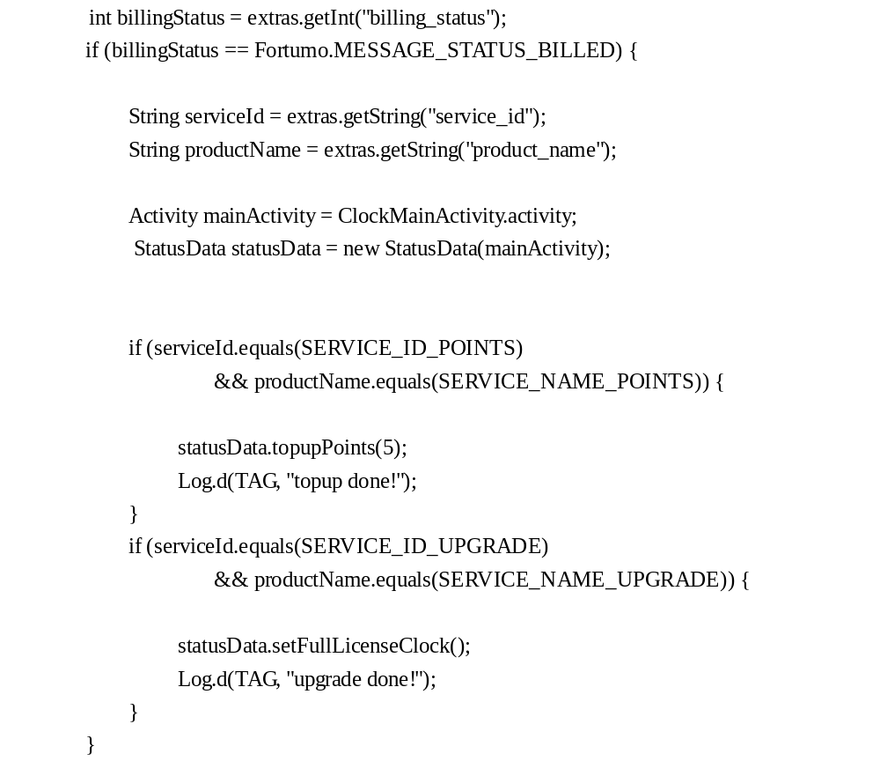

Run the Step3 project and debug and make it works in Emulator and on device. Refer to the sample project Step3.

Part5. Clock with Fortumo and NOOK billing

In this section, we combine Step2 and Step3 features into one application Step4. It supports Fortumo payment on normal Android devices, and NOOK credit card payment on NOOK devices.

Your Tasks:

Copy Step3 project into Step4 project, and rename class com.clock.step3 to com.clock.step4 in all class and configuration files. Make sure the application is workable under Step4 project

Follow instructions, add following two parts to AndroidManifest.xml to allow mobile operator billing:

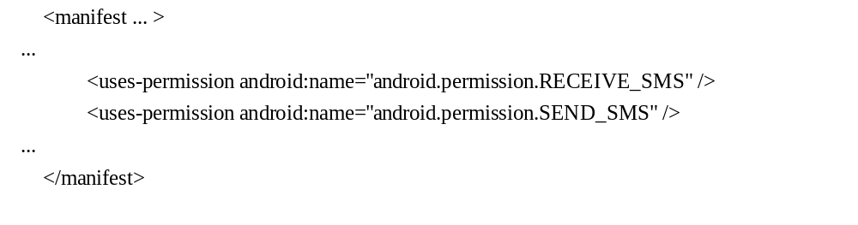

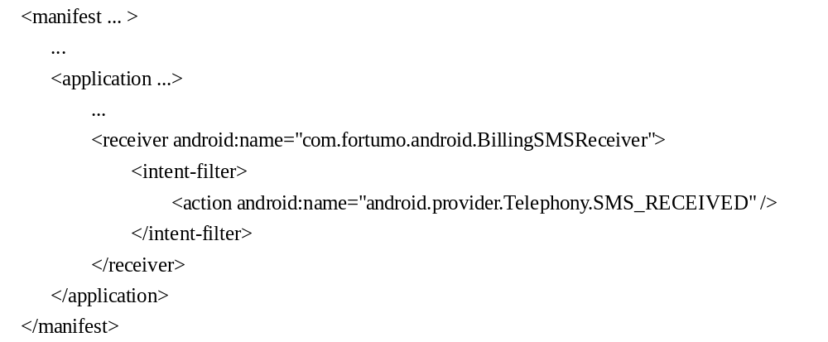

Detect if it is NOOK device

Create a new function Boolean isNOOK() in class ClockMainActivity

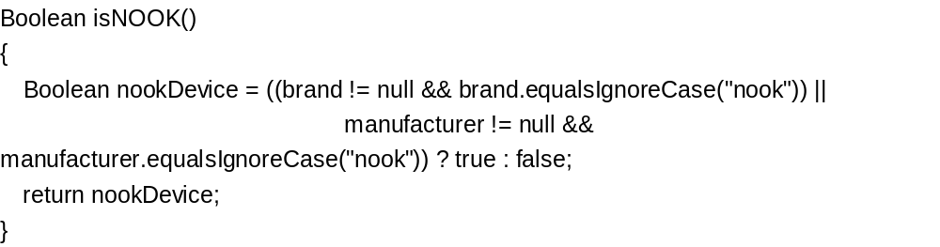

Call isNOOK() in ClockMainActivity.onCreate() and save the value into StatusData

Add two new member functions setNOOKDevice() and isNOOKDevice() to StatusData Class

Call StatusData.isNOOKDevice() in Pay4Points and Pay4Upgrade(), then call different payment functions based on the device type

Handle 4 types of response messages in PaymentStatusReceiver: ANDROID_PAY4POINTS, ANDROID_PAY4UPGRADE, NOOK_PAT4POINTS and NOOK_PAY4UPGRADE, store status data into StatusData object

Change function StatusData.isFullLicenseClock() so that if can not find the isFullLicense flag in local storage, it will check with Fortumo server if the user has purchased the Full License before. It uses API getNonConsumablePaymentStatus in an AsyncTask. Refer to the solution.

